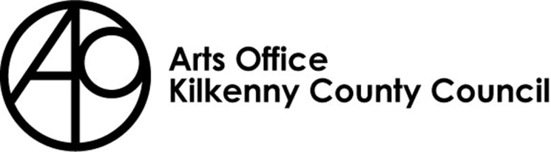

KILKENNY POETRY BROADSHEET 2020
ISSUE 20 - APPLICATION FORM

Kilkenny County Council Arts Office is now inviting submissions from poets born or based in Kilkenny City and County for the 20th Issue of Kilkenny Poetry Broadsheet.

We are delighted to announce that Colm Keegan will be editor of this year’s Broadsheet.
Colm Keegan is a writer and poet from Dublin, Ireland. He has been shortlisted four times for the Hennessy New Irish Writing Award, for both poetry and fiction and won the All Ireland Poetry Slam in 2010. His first book “Don't Go There” was released to critical acclaim in 2012. His latest collection “Randomer” is out now and available from Salmon poetry.

In 2014 he was awarded a residency in the LexIcon, Ireland’s largest public library. He has developed numerous creative writing projects for schools and colleges across the country. He is a creative writing teacher and co-founder of the Inklinks Project, a writing initiative for young writers. He was a co-founder and board member of Lingo, Ireland’s first Spoken Word festival.

Rules of Submission

Submissions can be in English or Irish

Submissions must be the work of the entrant (no third party submissions)

Entrants must be 18 years of age or over

No electronic submissions accepted. Submissions must be in hard copy

Limit of TWO entries per person.

Submissions MUST be typed and no longer than 30 lines

Work MUST NOT be signed

Entrants must be born or based in Kilkenny City or County

Submissions may have been published previously

Details of any such publication must be included with your application

The editor’s selection of published and shortlisted poems is final
- To be accepted for publication the editor may suggest edits to your poem/s for your consideration
- There is no submission fee but entries will not be returned

The closing date for submissions: no later than 4pm on Friday 27th March 2020

Return entries to: Kilkenny Arts Office, 5 Dean Street, Kilkenny R95 HD79

Please mark envelopes ‘Kilkenny Poetry Broadsheet’
Further information 056 7794547 / deirdre.southey@kilkennycoco.ie

KILKENNY POETRY BROADSHEET ISSUE 20

APPLICATION FORM

Name in full (Block letters)

Postal address

________________________________________
________________________________________
________________________________________

Tel. Number

Email Address

Title of Work(s)

- ___________________________________
- __________________________________________

Have you had work(s) (those submitted here or otherwise)
published previously?
Yes No

_______________________________________________
_______________________________________________
_______________________________________________
_______________________________________________
_______________________________________________
_______________________________________________

If so, please give brief details

I consent to the holding and processing of my personal data for the purposes of this application only and I understand that it will not be used for any other purposes.
I confirm that I am 18 years of age or over and I was born or resident in Kilkenny.

Signed: ____________________________ Date:________________________________

